Unit 7 Study Guide
Section 1: Cold War
- What was the Iron Curtain?

- Who controls production in a communist economy?

- The expansion of communism into Eastern Europe occurred directly after what event?

- What is Sputnik?

- What is a satellite state?

- What was the Berlin Wall?

- Why was the US and USSR reluctant to become involved in direct military conflict with each other?

- What is containment?

- What were the two East Asian wars that the US fought in that were between a communist half and a non-communist half?

- What was the Cuban Missile Crisis?

Section 2: Chinese Revolution
- Who was Mao Zedong?

- What changes did Mao bring to China?

- What was the “Great Leap Forward?”

- How was Mao and the communists able to gain control of China? (hint: they had a group’s support)

- What was the Tiananmen Square massacre?

- What are some current issues in China?

Section 3: Collapse of European Imperialism
- When did European Imperialism end?

- Define the following terms:
  - Mohandas Gandhi

  - Nelson Mandela

  - Apartheid

  - Khmer Rouge

  - Pol Pot

  - Ho Chi Minh

  - Fidel Castro

Section 4: Israeli-Palestinian Conflict
- What religion are most Palestinians?

- What religion are most Israelis?

- What is Zionism?

- What imperial power owned Palestine during World War I?

- Analyze the map below. What is happening over time? Why?

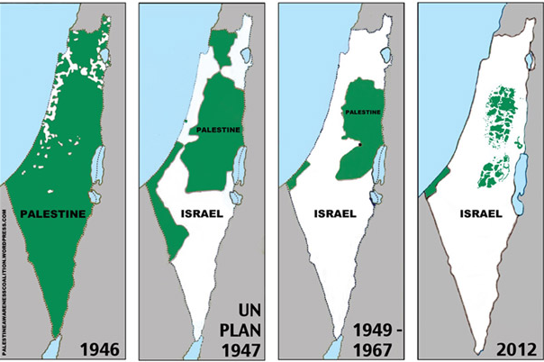

- What were the Camp David Accords?

Section 5: World Economies
- What is a command economy?

- What is a market economy?

- The United States is a _____________ economy.

- The Soviet Union was a _______________ economy.

- What are some common issues / obstacles with developing nations’ economies?

- What does O.P.E.C do?

