DBQ DISCUSSION: RUSSIAN REVOLUTION

Step 1: As you read each document, use the annotated reading strategy. Then analyze the document according to HIPP… choose at least two for each document and circle the choices you are making with EACH document.

Step 2: After you are finished reading each of the documents, use the graphic organizer on the last page to prepare for a discussion on the following focus questions:

Were the Russian people better off after the Russian Revolution? Was Communism the problem or was it Stalin?

CCSS.ELA-Literacy.SL.9-10.1 Initiate and participate effectively in a range of collaborative discussions with diverse partners on high school topics, texts, and issues, building on others’ ideas and expressing their own clearly and persuasively.

Document 1
Czar Nicholas II, 1896.
“I am not yet ready to be Tsar. I know nothing of the business of ruling.”
What does this quote say about the Czar Nicholas as a leader? What kind of feeling do you think he inspires in his subjects?

Document 2
Pavel Miliukov, in speech given to the Duma, November 1916

Is this incompetence or is it treason? Does it matter practically speaking whether we are dealing with incompetence or with treason?...The government persists in claiming that organizing the country means organizing a revolution and deliberately prefers chaos and disorganization.

What does this quote reveal about the attitude towards the government by the Russian People?

Document 3
First World War Encyclopedia by John Simkin, 2009.
Countries | Total Mobilized | Killed & Died | Wounded | Prisoners & Missing | Total Casualties | Casualties % Mobilized
Allied Powers
Russia | 12,000,000 | 1,700,000 | 4,950,000 | 2,500,000 | 9,150,000 | 76.3
France | 8,410,000 | 1,357,800 | 4,266,000 | 537,000 | 6,160,800 | 76.3
British Empire | 8,904,467 | 908,371 | 2,090,212 | 191,652 | 3,190,235 | 35.8
Italy | 5,615,000 | 650,000 | 947,000 | 600,000 | 2,197,000 | 39.1
United States | 4,355,000 | 126,000 | 234,300 | 4,500 | 364,800 | 8.2
Total | 42,188,810 | 5,152,115 | 12,831,004 | 4,121,090 | 22,104,209 | 52.3
Central Powers
Germany | 11,000,000 | 1,773,700 | 4,216,058 | 1,152,800 | 7,142,558 | 64.9
Austria-Hungary | 7,800,000 | 1,200,000 | 3,620,000 | 2,200,000 | 7,020,000 | 90.0
Ottoman Empire | 2,850,000 | 325,000 | 400,000 | 250,000 | 975,000 | 34.2
Bulgaria | 1,200,000 | 87,500 | 152,390 | 27,029 | 266,919 | 22.2
Total | 22,850,000 | 3,386,200 | 8,388,448 | 3,629,829 | 15,404,477 | 67.4
Grand Total | 65,038,810 | 8,538,315 | 21,219,452 | 7,750,919 | 37,508,686 | 57.6

Based on this chart, how was Russia doing during World War I? How would the Russian citizens feel?

Document 4
John Reed, Ten Days that Shook the World (New York: International Publishers, 1934).
All Russia was learning to read, and reading—politics, economics, history—because the people wanted to know. . . . In every city, in most towns, along the Front, each political faction had its newspaper—sometimes several. Hundreds of thousands of pamphlets were distributed by thousands of organisations, and poured into the armies, the villages, the factories, the streets. The thirst for education, so long thwarted, burst with the Revolution into a frenzy of expression. From Smolny Institute alone, the first six months, went out every day tons, car-loads, train-loads of literature, saturating the land. Russia absorbed reading matter like hot sand drinks water, insatiable. And it was not fables, falsified history, diluted religion, and the cheap fiction that corrupts—but social and economic theories, philosophy, the works of Tolstoy, Gogol, and Gork.

What impact did education play in the Russian Revolution?

Document 5
"Comrade Lenin Sweeps the Globe Clean", 1920
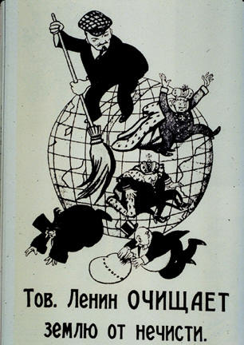

What goals does Vladimir Lenin hope to accomplish according to this document?

Document 6
Accomplishments and goals of Stalin’s Five Year Plan
What was the overall goal of the Five Year Plan?

Document 7
This excerpt, from The Land of the Soviets, published in the U.S.S.R, describes the results of the Five Year Plans.

The fulfillment of the first and second Five Year Plans strengthened the Soviet Union’s economic position and turned it into a powerful industrial state. . . . In 1937 the industrial output of the USSR was 5.8 times larger than in 1913. The rate of industrial growth in the USSR considerably exceeded that of the capitalist countries. By 1937 the Soviet Union was the first country in Europe and the second in the world in the volume of industrial production. . . . Socialist industrialization was accompanied by the rapid growth of the working class, and made it possible to liquidate unemployment. In 1940 there were 9,971,000 industrial workers, which was nearly three times more than in 1928. The working class was also changing: its efficiency, technical and cultural levels were growing rapidly.

What was effect did the Five Year Plans have on the Soviet economy?

Document 8
Agricultural production during Stalin’s first and second Five Year Plans.

What was the impact of the Five Year Plan on Soviet agriculture?

Document 9
Russian political cartoon; published in 1917
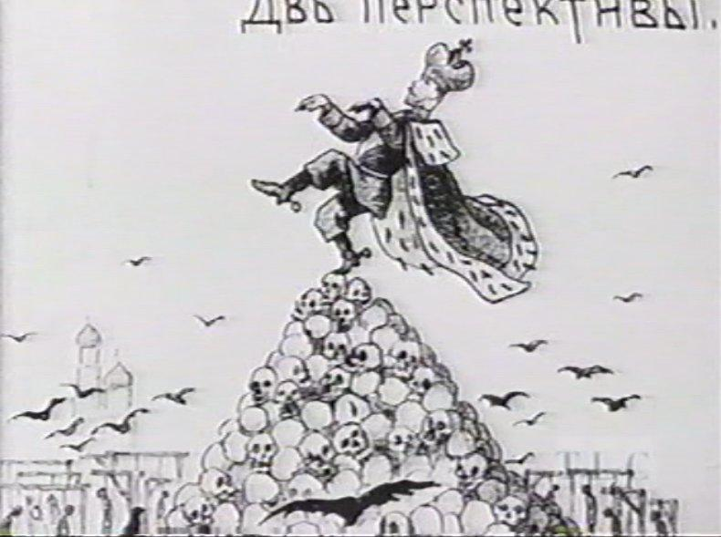

. What is the opinion of the Russian people toward Czar Nicholas? Use evidence from the political cartoon.

Document 10
This excerpt, from “Forced Famine in the Ukraine: A Holocaust the West Forgot” by Adrian Karatnycky,
was printed in The Wall Street Journal, on July 7, 1983.

Today, reliable academic estimates place the number of Ukrainian victims of starvation at 4.5 million to 7 million. . . . The famine was in part the by-product of Stalin’s relentless drive to collectivize Soviet agriculture. The famine was a clear result of the fact that between 1931 and 1933, while harvests were precipitously declining, Stalin’s commissars continued to . . . confiscate grain. Peasants were shot and deported as rich, landowning “kulaks”. . . . While the drive to collectivize agriculture was a wide- ranging phenomenon common to the entire U.S.S.R., only in the Ukraine did it assume a genocidal character. Indeed there can be no question that Stalin used the forced famine as part of a political strategy whose aim was to crush all vestiges of Ukrainian national sentiments.

What is a collective farm?

Based on this excerpt, what effect did collectivize agriculture have on the Soviet Union?

Document 11
In this excerpt, the French ambassador to the Soviet Union described the public trials that were part of the “great purges” of Stalin.

I personally attended the second and third Moscow trials, those of 1937 and 1938. . . . Pyatakov [another defendant] arose . . . confessed . . . to a number of crimes. Did these “confessions” carry any share of truth? It is possible that the accused were hostile to Stalin’s regime. . . . But the lessons they recited must have been forced from them . . . it is more likely that the GPU [secret police] touched each at his weak point. It is also probable that the accused gave in to some form of pressure. . . . Some would give in to save their families, others in the hope of saving their own lives.

Based on the document, why were the court proceedings suspicious?

Document 12
Robert Conquest, The Great Terror, 1968.
Estimates of those arrested, executed, and incarcerated under the height of Stalin’s “Purge”:
- Arrests, 1937-1938 - about 7 million
- Executed - about 1 million
- Died in camps - about 2 million
- In prison, late 1938 - about 1 million
- In camps, late 1938 - about 8 million
- Surviving camps: less than 10%
- 98% of those dead were male

What is happening in Stalin’s Purge?

Discussion Focus Question: Were the Russian people better off after the Russian Revolution? Was Communism the problem or was it Stalin?

Examples of how life improved (include sources) | Examples of how life worsened (include sources)

