Classical Civilizations Project: Greece and Rome
Over two days you will be doing research and creating a project on an aspect of Greece and Rome. You can create either a PowerPoint or Prezi to present your work. Below is a list of topics for you to research. Choose one and you will compare/contrast your topic in Greece and Rome.
The first day should be spent on researching your topic in Greece and the second day focusing on your topic in Rome. Make sure your information is organized in a clear way and that you have edited your work for grammar and spelling errors. Your final product should contain around 10 slides.
Possible Topics
- Architecture
- Art
- Clothing
- Food and Drink
- Government and Leaders
- Language
- Law/Legal System
- Medicine
- Military
- Religion (Christianity vs. Mythology)
- Science and Technology
- Sports
- Transportation
Your project should include the following:
- Title
- Multiple slides of info on topic in Greece
- Multiple slides of info on topic in Rome
- Images on each slide
- Bibliography
You should begin your research on the following websites:
- Greece - http://www.crystalinks.com/greece.html
- Greece - http://www.ancientgreece.com/s/Main_Page/
- Rome - http://www.crystalinks.com/rome.html
- Rome - http://www.historylearningsite.co.uk/ancient-rome/

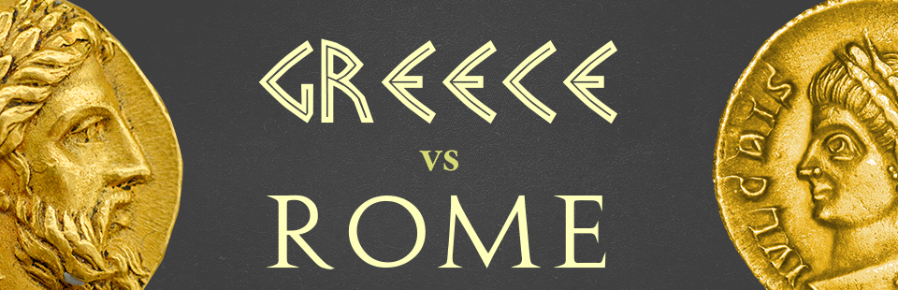
*DO NOT COPY AND PASTE INFORMATION DIRECTLY FROM A WEBSITE. THIS IS PLAGIARISM AND WILL RESULT IN A ZERO. *

